

Target: ___/65 or ____ % 👍 👎

**Year 7 – Humanities and Social Sciences**

**Task 1 – Water in Australia and Northern Africa (5%)**

Topic: Water Scarcity

65

(Part A: Inquiry Booklet & Part B: Poster)

**Name: _____________________________________________________**

**Curriculum:** Water scarcity and what causes it, why it is a problem and ways of overcoming water scarcity e.g. **reducing water consumption,** including studies drawn from Australia.

**Your Task:**

Create a poster which educates people about water scarcity. The poster must provide an overview of the issue of water scarcity and then focus on the causes and impacts of water scarcity in **Australia** and a country in Northern Africa. The poster must include the strategies that are used to manage water scarcity and a proposal for further action that is required to manage the issue in both countries.

**You will need to design a poster which addresses the following key areas;**

* Define the issue of water scarcity.
* The causes and impacts of water scarcity in Australia.
* The causes and impacts of water scarcity of a country in Northern Africa.
* Management strategies that are being used in Australia and the country in Northern Africa.

The information must be supported by the use of statistics, graphs and maps.

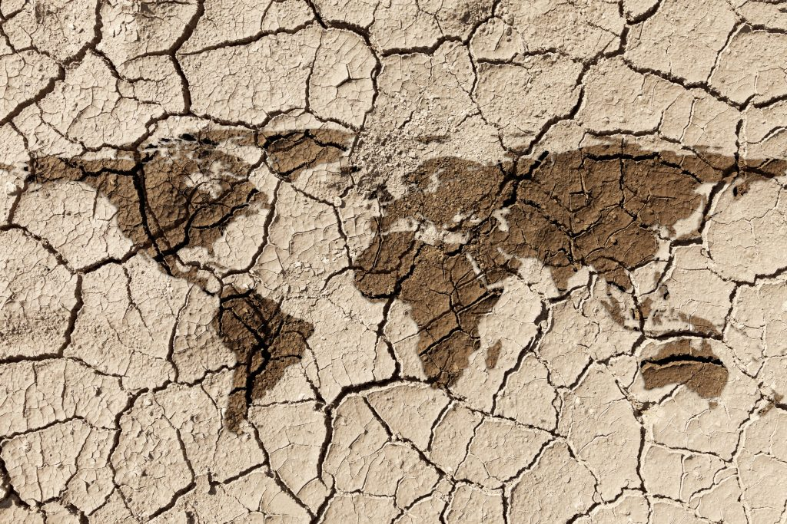You must also submit a **bibliography.**

https://www.thesourcemagazine.org/three-steps-solving-water-scarcity-creating-climate-resilience/

1. **Brainstorm (10 marks)**

*In the space below brainstorm the elements of a poster and the purpose of this task.*

1. **Developing Questions**

*Complete the KWL chart below about the topic of the inquiry.*

|  |  |  |
| --- | --- | --- |
| What do you **KNOW** about the topic? | What do you **WANT** to know about the topic? | What have you **LEARNT** about the topic? |
|  |  |  |

1. **Planning your inquiry.**

*In the space below, list sources of information that you could use to research your focus questions.*

1. **Note taking**

When you are finding information in books and on the internet, it is not efficient or useful to copy down page after page of information without organising it into a neat and systematic set of notes. Instead, you need to set out a series of notetaking pages, with each page addressing a different question. Do not write more than one question per page.

Your note taking page needs to have the following:

* Question number
* Question
* Key Words
* Notes
* Bibliography Reference

It is important that your notetaking is structured, your work should reflect how best you like to learn and organise your information.

Here are some tips for note taking:

* Different focus questions may need different styles of notetaking. Try a range of formats.
* Use a different coloured pen for each source you use. Don’t forget to also record bibliography details in the same coloured pen at the bottom of the page.
* Highlight direct quotes
* Only use dot points and key words – do not copy down full sentences!
* Use symbols, abbreviations and diagrams in your notes
* Make your notes clear and not cramped on the page
* All notes must be hand written
* Hand in all your notes, not matter how messy they are, but they should be neat.

|  |  |
| --- | --- |
|  | **Question:** |
|  | *Key Words* |
| *Notes* |
| *Bibliography - References* |
| 2. | **Question:** |
|  | *Key Words* |
| *Notes* |
| *Bibliography - References* |
| 3. | **Question:** |
|  | *Key Words* |
| *Notes* |
| *Bibliography - References* |
| 4. | **Question:** |
|  | *Key Words* |
| *Notes* |
| *Bibliography - References* |
| 5. | **Question:** |
|  | *Key Words* |
| *Notes* |
| *Bibliography - References* |

1. **Plan and Draft**

Use the space below to **plan** your poster. Remember to ensure you include all the elements required to make your poster informative.

1. **Create your Poster**

Create your poster, ensure it is engaging and check that you have addressed all the areas required by the task.

1. **Create Bibliography**

*Bibliography – a list of all the source you have referred to throughout your inquiry.*

You need to create a correctly formatted bibliography for any inquiry that you do. Record all the details of every source you access in your bibliography.

The rule is – **if you SIGHT it – CITE it!**

*Plagiarism – the practice of taking someone else’s work or ideas and passing them off as one’s own***.**

Narrogin Senior High School has a ZERO TOLERANCE POLICY regarding plagiarism.

**Books**

**Example**: Stephens, David. 2017. *The Honest History Book*. Sydney, NSW: NewSouth Publishing.

|  |  |  |  |  |
| --- | --- | --- | --- | --- |
| Author’s Surname | Author’s First name | (Year Published) | *Book Title (in Italics)* | Place of Publication: Book Publisher. |
| , | . | . | . | . |

**Websites**

**Example:** Smith, Peter. 2001. *Coral.* <http://www.greatbarrierreef.gov.au> Accessed: 20th February 2019.

|  |  |  |  |  |  |
| --- | --- | --- | --- | --- | --- |
| Author’s Surname | Author’s First name | (Year Published) | *Website Title (In Italics)* | Website URL | Date you used the website. |
| , | . | . | . | . | Accessed: |

Once you have created your reference, all references are organised on a new page in ALPHABETICAL order by the author’s surname.

1. **Print and Submit**

Print and submit your inquiry to your teacher by the due date.

You must submit:

* Inquiry Booklet
* Poster
* Bibliography

**Detailed Marking Guide/Rubric (Inquiry Booklet)**

|  |  |  |  |  |  |  |
| --- | --- | --- | --- | --- | --- | --- |
| **Task 🡫 &**  **Marks Allocation 🡪** | **0 – 2** | **3 – 4** | **5 – 6** | **7 – 8** | **9 – 10** | **Total** |
| **Brainstorm** | Only 1-2 examples of the topic and the task. No detail is used.  No Brainstorm is submitted (0) | Provides some examples of the topic and the task. States basic examples, with limited specific information. | Provides detailed and comprehensive examples of the topic. Expands on examples by stating more than one word. Provides specific information. |  |  | **/ 6** |
| **KWL Chart** | Presents a less detailed KWL chart. Less comprehensive reference to key areas. Some sections are incomplete or the chart is not finished, with sections missing. | Presents a generalised plan and/or limited chart. Limited references are made to key areas. Sections are missed.  No KWL Chart is submitted (0) | Presents a very detailed and comprehensive chart, through the use of a well-structured KWL Chart. Comprehensive detail is used in each section of the KWL chart, which relates clearly to the task and the key areas. |  |  | **/ 6** |
| **Notetaking** | Provides limited and/or no extra notes. Does not complete the section. Examples are not demonstrated throughout.  No extra notes are submitted (0) | Provides basic notes. Addresses research areas in limited detail and uses a few examples for supporting evidence. Uses some notetaking conventions. | Provides generalised notes. Addresses research areas in some detail and uses some examples for supporting evidence. Attempts to following notetaking conventions (dot points, symbols). | Provides less detailed and mostly accurate notes. Addresses research areas mostly in detail and uses various examples for supporting evidence. Follows notetaking conventions (dot points, symbols etc.) | Provides very detailed, comprehensive and accurate notes. Addresses research areas in detail and uses extensive examples for supporting evidence. Uses evidence from a range of sources. Follows notetaking conventions (dot points, symbols etc.) | **/ 10** |
| **Bibliography** | No bibliography submitted (0)  Bibliography includes a limited list of sources which may follow the referencing technique approved by the school. | Uses the minimum 5 sources (2 books) and bibliography includes a smaller range of sources which mostly follow the referencing technique approved by the school. | Uses the minimum 5 sources (2 books) and collects information from a comprehensive number of sources and records a variety of key information which relates to strategies to the topic. Incorporating ethical protocols, which correctly follow the referencing technique approved by the school. |  |  | **/ 6** |
| **Detailed Marking Guide/Rubric (Poster)** | | | | | | |
| **Task 🡫 &**  **Marks Allocation 🡪** | **0** | **1** | **2** | **3** | **4** | **Total** |
| **Title** | No title is included. | An appropriate headline is included. |  |  |  | **/2** |
| **Student name is included** | Student’s name is not included. | Student’s name is included. |  |  |  | **/2** |
| **Task 🡫 &**  **Marks Allocation 🡪** | **0** | **1** | **2** | **3** | **4** | **Total** |
| **Definition of Water Scarcity** | No definition is included. | A basic definition of Water Scarcity is included. | A detailed definition is included with examples. |  |  | **/2** |
| **Causes of Water Scarcity in Australia** | Provides no information. | Provides basic and limited information about the causes of water scarcity in Australia. | Provides satisfactory information about the causes of water scarcity in Australia. Includes statistics, graph/and or map. | Provides very good about the causes of water scarcity in Australia. Includes statistics, graphs and a map. | Provides excellent information about the causes of water scarcity in Australia. Includes statistics, graphs and maps. | **/4** |
| **Impacts of Water Scarcity in Australia** | Provides no information. | Provides basic and limited information about the impacts of water scarcity in Niger. | Provides satisfactory information about the Impacts of water scarcity in Australia. Includes statistics, graph/and or map. | Provides very good about the Impacts of water scarcity in Australia. Includes statistics, graphs and a map. | Provides excellent information about the Impacts of water scarcity in Australia. Makes references to the sources included. Includes statistics, graphs and maps. | **/4** |
| **Causes of Water Scarcity in Niger** | Provides no information. | Provides basic and limited information about the causes of water scarcity in Niger. | Provides satisfactory information about the causes of water scarcity in Niger. Includes statistics, graph/and or map. | Provides very good about the causes of water scarcity in Niger. Includes statistics, graphs and a map. | Provides excellent information about the causes of water scarcity in Niger. Makes references to the sources included. Includes statistics, graphs and maps. | **/4** |
| **Impacts of Water Scarcity in Niger** | Provides no information. | Provides basic and limited information about the Impacts of water scarcity in Niger. | Provides satisfactory information about the Impacts of water scarcity in Niger. Includes statistics, graph/and or map. | Provides very good about the Impacts of water scarcity in Niger. Includes statistics, graphs and a map. | Provides excellent information about the Impacts of water scarcity in Niger. Makes references to the sources included. Includes statistics, graphs and maps. | **/4** |
| **Management Strategies use in Australia** | Provides no information. | Provides basic and limited information about the Management strategies used to address water scarcity in Australia. | Provides satisfactory information about the Management strategies used to address water scarcity in Australia. Includes statistics and pictures/diagrams. | Provides very good about the Management strategies used to address water scarcity in Australia. Includes statistics and pictures/diagrams. | Provides excellent information about the Management strategies used to address water scarcity in Australia. Makes references to the sources included. Includes statistics, pictures/diagrams. | **/4** |
| **Management Strategies use in Niger** | Provides no information. | Provides basic and limited information about the Management strategies used to address water scarcity in Niger. | Provides satisfactory information about the Management strategies used to address water scarcity in Niger. Includes statistics and pictures/diagrams. | Provides very good about the Management strategies used to address water scarcity in Niger. Includes statistics and pictures/diagrams. | Provides excellent information about the Management strategies used to address water scarcity in Niger. Makes references to the sources included. Includes statistics, pictures/diagrams. | **/4** |
| **Spelling, punctuation and editing.** | Frequently misspells common words, consistently makes punctuation errors and identifies very few or no errors in own writing. | Misspells some common words and familiar difficult words, makes punctuation error which detract from meaning and finds some errors in own work. | Spells most words correctly, misspells some new technical words and edits own work to improve content, structure and vocabulary. | Spells most words correctly, uses most punctuation accurately and edits own work to make content clearer and to improve vocabulary. | Spells difficult words accurately, uses varied punctuation for clarity and precision of meaning and consistently uses editing strategies to demonstrate control over content. | **/4** |
| **Overall Presentation** | No effort to make the poster engaging. | Little effort is used to make the poster engaging. | Poster is engaging, colour is used, and formatting is satisfactory. | Poster is very engaging and informative. |  | **/3** |

**Total Marks _______________ / 65**

**Teachers Comments:**

|  |  |
| --- | --- |
| **What was done well:** |  |
| **What to improve next time:** |  |
| **What will you do differently in your next inquiry task?** |  |